21.14: We only need the y-components, and each charge contributes equally.
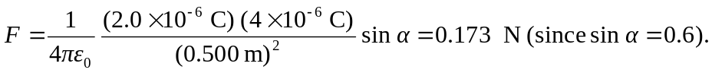
Therefore, the total force is 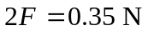, downward.

